Supporting Materials for:

Title – ISCAP Proceedings Submissions
Upper and Lower Case

Initial Submission: Leave space (5 lines) for Author Information to be inserted later.
Please make sure you update all author information
in the papers system as you submit and upload (or reupload).

Name
Email
Univeristy
City, State, Zip, Country.

Hook
The “hook” statement should generate interest in the case of activity. This of this like a phrase that you might see for a poster advertising a motion picture. The word “Hook” should be in 12 bold.

Abstract

The abstract should summarize the content of the paper. Make it a single paragraph. Try to keep it below 250 words and do not include equations or references in it. If you use abbreviations in the paper, i.e., CIS, use the full meaning of the abbreviation in the abstract or at first use, i.e., Computer Information Systems. The word “Abstract” should be in 12 bold.

Keywords: Select four to six keywords that capture the essence of the paper. List the words in decreasing order of importance from left to right, with commas between the key word concepts. (Enter the Keywords into the papers system)

Insert your paper title
here in Verdana - 14 font.

Leave this line here to insert author names in the final format

- SUPPORTING MATERIALS GUIDELINES

For teaching cases, it is recommended that authors include supporting materials.

These should be materials that make it easier for a reader to adopt the case. Examples of materials include, but are not limited to, instructor notes, PPTs, spreadsheets, worksheets, etc.

Instructor notes should follow the formatting guidelines provided below. In terms of content, these notes should provide instructors with information needed to successfully utilize the teaching case. This may include additional background information, tips or tricks, or issues that may occur and how they can be remedied.

There are no specific guidelines for other forms of supporting materials other than ensuring that all metadata is removed.

Metadata for these all materials should be removed in the same manner as the case itself: File > Info > Check for Issues > Inspect Document >Document Inspector > Document Properties and Personal Information > Remove All.

Supporting materials should be in separate file(zip) and uploaded after you submit the case. Please note your zip file must be less than 4 MB to be uploaded, if it is larger than 4 MB send directly to the case editor (cases@isedj.org) with the case # in your email.

2. FORMATTING GUIDEINES

Formatting is the same for both Conference and Journal submissions, regardless of whether the submission is an article or a teaching case. This template is needed only for the submission of supporting materials.

It is suggested that authors use this template for their work, as it is already appropriately formatted.

In the interest of consistency, the formatting directions for supporting materials are the same as those for conference submissions and journal articles.

3. PREPARATION OF MANUSCRIPTS

Major headings are to be centered, numbered, in a capitalized bold font as shown in this document. Leave a blank row before and after Major Section Headings. Do not use the Microsoft Paragraph Numbering Option as it will not center the heading properly.

1.1 Subheadings

Subheadings should be bold font with initial capitals and left-justified. Insert one line before the subheading title, and one line after the subheading. Number the subsections manually and do not use the MS numbering option.

Both major headings and subheadings should be set to “Keep with Next” so that they stay with their content as the paper may be slightly edited.

1.2 Figures / Tables

Figures and tables should be placed in the manuscript on the page where they are referenced (if they fit). Please attempt to have your figures and tables to span only one page. Larger tables and figures should be moved to the appendix. Use Section Breaks (Continuous) to maintain the location to of your tables and figures. Do not place the descriptions of figures / tables in text boxes.

Place the identifying information about tables and figures below the Figure or Table in bold and centered. Do not use italics. Use a period to separate the table or figure number from a brief and descriptive caption. They should be numbered consecutively throughout the text.

You also have the option to place large tables and figures in the appendix.

1.3 Formulae

All equations must be typed utilizing a suitable processor. They should be numbered consecutively throughout the text, at the flush-right edge of the equation, enclosed in parentheses. It is acceptable to present formulas as images if necessary.

4. CONCLUSIONS

The enhancements to information systems education are identified or repeated here. DO NOT repeat the abstract or portions of it.

5. ACKNOWLEDGEMENTS

Place before the references.

6. FOOTNOTES

Use endnotes instead.

7. REFERENCES

We request you follow the current APA (American Psychological Association) guidelines to cite sources. Please include Digital Object Identifiers (DOI) links for all references where possible. DOI citations should follow the APA guidelines.

Following are examples of typical citation items:
Ashby, W. Ross (1956). An Introduction to Cybernetics. Methuen Press, London. (Book)
Harris, A. (2009). Publishing in JISE. Journal of Information Systems Educators, 7(1), 12-15. https://doi.org/xxxxx (Journal with 1 Author and DOI reference).
Harris, A., & Harris J. (2010). Publishing in JISE. Journal of Information Systems Educators, 7(1), 12-15. https://doi.org/xxxxx (Journal with 2 Authors)
Harris, A., Harris J., & Colton D. (2011). Publishing in JISE. Journal of Information Systems Educators, 7(1), 12-15. https://doi.org/xxxxx (Journal with 3 or more Authors)
Hunsinger, S. (2010). My life with Word Press. In M. Smith (Ed.), Word Press in the 21st Century . High Point Press. (Book Chapter with Editor)
Sample, P., & Canary, W. (2008). Why Web 2.0 implies I should get a raise. New England Online Education 7(12). Retrieved June 6, 2010 from https://giveaddress.com/xxx (On line Journal or Publication or Article)
White, K. B. (2009, June 1). Why June is a great month to submit an article to ISCAP. Chronicle of Higher Education, 22(7), 15-16. (Magazine Article)

When citing references in the text, include the last name and year. The citation should appear in parentheses such as (Ashby, 1956) or, if you need to comment about Ashby (1956) stated we are great.
Two author papers should be cited in the document as (Harris & Witman, 2009).
Three or more authors in a paper should be cited with the name of the first author and “et al.” in each instance, including the first citation: (Harris et al., 2009). The only exception would be if doing so would create ambiguity.
If two or more papers are cited by the same author, separate the years with commas. Identical years for the same author should appear as (2009a) and (2009b) in the body of the document as well as the references.
If the author of a paper is not provided, alphabetize according to the title of the work. If the first word in the title is a number, alphabetize as if the number were a written word, for example, “10 Best Practices” would be alphabetized as though it were written as the word “ten.”

Appendices

Typically, an appendix or annexure will include actual handouts given in class, or questionnaires used for surveys, or other presentation graphics and tables that do not fit readily into the body of the paper but are still important for clarity or completeness. Often these items were prepared for other purposes than presentation as a part of your paper, and it is acceptable that they do not adhere to font face, font size, and column requirements observed elsewhere in your paper.

In appendices, you are allowed to have margins that are larger but not smaller than the generally required margins, which are 1.0 top margin, 1.0 bottom margin, 1.0 left margin, and 1.0 right margin

So long as you adhere to the margin requirements, appendices may be presented in any format that you desire.

Rotated pages (landscape orientation) are not allowed in the body of the document, but they are permitted in the appendices. This will allow the entire page to be rotated anti-clockwise 90 degrees for final formatting.

Please label each appendix section with a serially lettered heading in all caps/bold, e.g., APPENDIX A. The following line should give title of that appendix section, in mixed case/bold, e.g., Title of Content for this Part of the Appendices.

See the next page for an example.

APPENDIX A

Sample 2-D Chart for Assignment 1

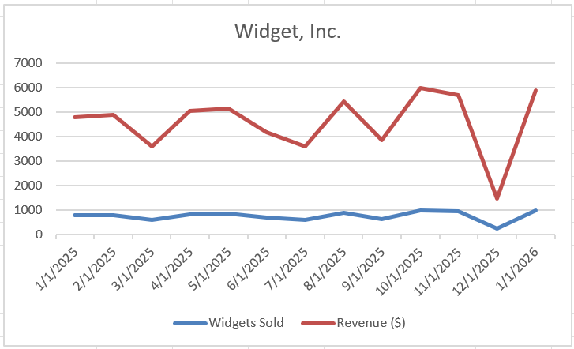

The more you can provide in terms of support the better. An appendix might have an answer key, sample answers, charts, graphs, tables, etc. The goal is to make it as simple as possible for the reader to use your case in class.

